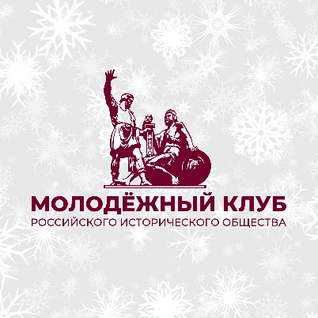
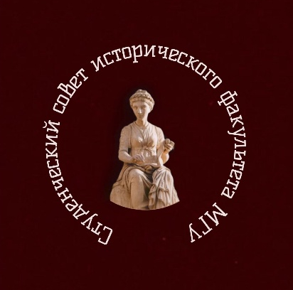



Dear colleagues!
We kindly invite you to participate
in the 5th International Interdisciplinary Scientific Conference of Students, Postgraduate Students and Young Scientists ‘‘Power and Society in the Historical Experience of Humanity’’,
which will be held on
20-21 March 2026

The Student Scientific Society, the Student Council of the Faculty of History of the Lomonosov Moscow State University and the Youth Club of the Russian Historical Society invite you to take part in the 5th International Interdisciplinary Scientific Conference for students and young scholars “Power and Society in the Historical Experience of Humanity”. The conference will be held in person (with an option for remote online participation) at the Lomonosov Moscow State University (Moscow, Russia) on March 20 – 21, 2026.
The dynamic of relations between institutions of power and the societies they govern has preoccupied thinkers and researchers throughout all the periods of human history and remains a central concern for the scholarly community today. Across various geographical regions, chronological periods, and specific historical contexts, this relationship has manifested itself in diverse forms, leaving its imprint on historical sources and collective memory.
Examining the nature of these relations (their regional and cultural peculiarities, the mutual influence of power structures and the public, and the evolution of the political languages that have facilitated their dialogue through various periods of human history) remains relevant for scholars from different countries and continents. Our conference aims to provide a forum for discussing current debates and breakthroughs on the subject and for sharing new research on the relationship between power and society across major periods of world history.
We welcome interdisciplinary submissions on topics including, but not limited to:
- Despotism and Democracy in the Ancient World;
- The Middle Ages: from local lordships to ‘absolute’ monarchies
- The Early Modern and Modern Era: the evolution of state institutions and political culture;
- The 20th and 21st Centuries: Power and Society during the Age of Modernization and Digitalization
- Government and Society in the history of Asia, Africa, and Latin America: common and peculiar issues;
- The evolution of political institutions in Medieval Rus’ and Early Modern Russia
- The development of interactions between power and societal structures in the Russian Empire (1721-1917);
- Soviet Russia as a ‘new model’ of the relationships between the government and society in Russian history;
- The arts and politics in World history;
- Relations between power and society based on archaeological findings and written sources.
Working languages of the conference: Russian and English.
We invite applications from BA, MA, PhD students and young researchers in history, anthropology, archaeology, art history, sociology, economics, philosophy, and related disciplines as well as from young researchers.
Applications for the conference, which should include an abstract of the presentation and a list of cited primary sources and literature (4,000 to 6,000 characters, spaces not included), should be submitted through the form (https://lomonosov-msu.ru/rus/event/10203/ ). The deadline for submissions is March 5, 2026.
Publication of a peer-reviewed conference collector of articles
Conference participants who have prepared high-quality and informative reports are invited to prepare articles based on their reports, which will be published in a peer-reviewed collection of conference materials indexed in the RSCI.
Based on the results of the conference sections, it is planned to publish a collection of articles indexed in the RSCI. Articles ready for publication should be sent to the conference's email address by July 5, 2026 at the latest.

For any inquiries, please contact the conference's email address:
hist.msu.konf@yandex.ru

Requirements for the design of articles and an example of the finished article in the conference collection see Appendix 1 and Appendix 2.
With respect, the Organizing Committee of the V International Interdisciplinary Scientific Conference of Students, Post-Graduate Students and Young Scientists "Power and Society in the Historical Experience of Mankind".

Appendix 1. Requirements for the design of articles
The volume of the article text should not exceed 20 thousand characters with spaces; with alignment, 1.5 interval; red line (indent-paragraph): 1.25; font Times New Roman; font size: 14. Margins are 2 cm on all sides (in Word, they are displayed in the "Layout" section, the "Fields" subsection, and the "Custom fields..." line).
Please note the difference between a hyphen, a dash, and a long dash, and avoid using word wrapping. Do not number the pages in the file!
Structure:
- Author's full name.
- Place of study, status: student, master's student, or postgraduate student, with course or year of study (in Russian and English), in italics, right-aligned.
- Title of the article in Russian and English: may differ slightly from the title of the conference report, bold, centered.
- A brief abstract in Russian and English (no more than 400 characters with spaces).
- Keywords in Russian and English (5-7 words or phrases).
- The text of the article. The text should have a coherent logical structure without grammatical or stylistic errors, and should include the following mandatory parts: introduction, relevance and source base of the research, purpose of the work, critical analysis of historiography, conclusions, and the author's concept. In case of any disputes, we will contact you and ask you to refine the text of the article.
- List of sources and literature: alphabetically, first in Russian and then in foreign languages.
References to literature or sources are placed in the text in square brackets, where the first number is the book number in the list of references (arranged in alphabetical order), and the second number is the page number. The page number is separated from the book number by a comma. If there are multiple references in square brackets, they are separated by a semicolon, for example: [1, p. 25] or [1, p. 25; 5, p. 23].
References to Internet resources are provided in the general list of literature by author and title of the publication, with the mandatory indication of the website address where the publication is located, and the date of its placement or the date of the last check for the availability of the resource.

Appendix 2. Article formatting example

Иванов Иван Иванович
Ivanov Ivan Ivanovich
Студент (аспирант) 1/2/3/4 курса бакалавриата (магистратуры)
Undergraduate Student / Master’s Student / Postgraduate Student of the 1st / 2nd / 3rd / 4th / 5th year [choose a year of study]
Исторического факультета МГУ им. М.В. Ломоносова
Faculty of History, Moscow State University

Название статьи
Article title
Abstract :
Keywords :
The text of the article
Text of the article. Text of the article. Text of the article [4, с. 12]. Text of the article. Text of the article. Text of the article. Text of the article. Text of the article. Text of the article. Text of the article. Text of the article. Text of the article. Text of the article. Text of the article. Text of the article. Text of the article. Text of the article. Text of the article. Text of the article. Text of the article.
Text of the article. Text of the article [10, p. 42]. Text of the article. Text of the article. Text of the article. Text of the article. Text of the article. Text of the article. Text of the article. Text of the article. Text of the article. Text of the article. Text of the article. Text of the article. Text of the article. Text of the article. Text of the article. Text of the article. Text of the article. Text of the article.
Text of the article. Text of the article. Text of the article [3, л. 2]. Text of the article. Text of the article. Text of the article. Text of the article. Text of the article. Text of the article [5, p. 49]. Text of the article. Text of the article. Text of the article. Text of the article. Text of the article. Text of the article. Text of the article. Text of the article. Text of the article. Text of the article. Text of the article. Text of the article [8, с. 2]. Text of the article.
Text of the article. Text of the article. Text of the article. Text of the article. Text of the article. Text of the article. Text of the article. Text of the article. Text of the article. Text of the article. Text of the article. Text of the article.

List of sources and literature

The hyphen is defined as a punctuation mark used to separate or join parts of a word. It should be shorter than a dash by at least two times, and its purpose is to divide parts of a word. It is also used to shorten words. Examples: pre-Columbian, ex-president. On a keyboard, it is inserted by pressing the "-" key.
A dash (also known as a "short dash") is defined as a punctuation mark used to indicate distances or a range of values, such as 55–70, 1914–1918. On a computer, it can be achieved by pressing the "ctrl" key and the "–" key (on the numeric keypad).
A long dash is also a punctuation mark. In Russian, it is placed: 1) between the subject and the predicate, if both are expressed by nouns in the nominative case (Александр Яковлев — архитектор перестройки = Alexander Yakovlev is the architect of Perestroika), a long dash is therefore usually used in definitions; 2) if the predicate is expressed by an infinitive, and the subject remains a noun; 3) A dash is placed before a generalizing word in a sentence if it follows a list. The keyboard shortcut is "ctrl" + "alt" + "-" (on the additional numeric keypad).

