

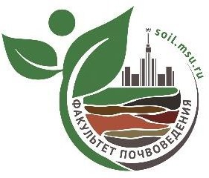 **Lomonosov Moscow State University**

**Soil Science Faculty**

**Russian Society of Soil Scientists**

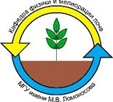



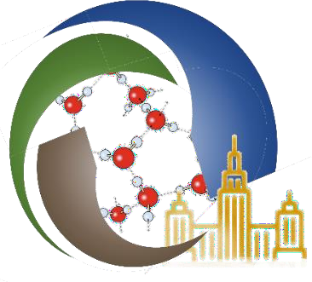**II INTERNATIONAL INTERDISCIPLINARY SCIENTIFIC YOUTH FORUM**

**STRUCTURAL AND FUNCTIONAL UNITY OF SOILS AND ADJACENT ENVIRONMENTS**

**In commemoration of the 270th anniversary of Lomonosov Moscow State University**

**I INFORMATION LETTER**

***Dear colleagues!***

The Soil Science Faculty of Lomonosov Moscow State University (MSU) invites you to participate in the II International Youth Forum on "Structural and Functional Unity of Soils and Adjacent Environments" to be held in Moscow from **July 19 to 25,** **2025.**

The Forum’s scientific program is based on the interdisciplinary nature of soil science and focuses on contemporary and emerging applications of its fundamental concepts, in conjunction with related sciences. The forum aims to bring together young scientists from different academic programs related to soil and environmental research, providing a platform to exchange advanced scientific insights, discuss prospects for development and cooperation, and foster international collaboration.

**Working languages:** Russian, English.

The forum will feature lectures by leading scientists, scientific excursions, field-based master classes, a poster session, and discussion/ debates sessions.

## PLANNED WORKING AREAS OF THE DISCUSSION / DEBATE SESSIONS

1. Acquisition of agricultural land, forests, parts of national parks, etc. by megalopolises (developers)
2. Urban agronomy in new suburban zones: pro and contra

## PLANNED AREAS OF REPORT TOPICS OF THE POSTER SESSION

1. Urban Meteorology.

2. Hydrothermal regimes of soils.

3. Factors, mechanisms and markers of biodiversity and sustainability of ecosystems.

4. Health of the urban environment.

5 Modern technologies and tools applied in Soil Sciences.

6. Soil health: indicators, descriptors, attributes, and strategies for improvement.

7. Hydropedology in urban environment.

**CONFERENCE PRESIDENTS**

|  |  |
| --- | --- |
| ***Aminat Umarova*** | Professor, Head of Department of Soil Physics and Reclamation, Soil Science Faculty of Moscow State University, Moscow, Russia |
| ***Said Al-Ismaily*** | PhD Soil Sciences, Head of Department of Soils, Water & Agricultural Engineering College of Agricultural & Marine Sciences, Sultan Qaboos University, Al‐Khoud, Sultanate of Oman |

**EXECUTIVE SECRETARIES**

|  |  |
| --- | --- |
| ***Konstantin Romanenko*** | Department of Soil Physics and Reclamation, Scientific Secretary of the V.V. Dokuchaev Society of Soil Scientists |

**PROGRAM COMMITTE**

|  |  |
| --- | --- |
| ***Afrah Al-Shukaili*** | PhD Soil Sciences, Department of Soils, Water & Agricultural Engineering College of Agricultural & Marine Sciences, Sultan Qaboos University, Al‐Khoud, Sultanate of Oman |
| ***Alexander Rappoport*** | PhD, Moscow State Botanical Garden |
| ***Andrey Smagin*** | Prof., Department of Soil Physics and Reclamation, Soil Science Faculty of Moscow State University, Moscow, Russia |
| ***Anastasia Gasina*** | PhD, Department of Soil Physics and Reclamation, Soil Science Faculty of Moscow State University, Moscow, Russia |
| ***Anna Fedotova*** | Prof., Federal Scientific Center of Agroecology of the RAS, Volgograd, Russia |
| ***Anna Ivanova*** | PhD, Department of Soil Biology, Soil Science Faculty of Moscow State University, Moscow, Russia |
| ***Anna Kokoreva*** | PhD, Department of Soil Physics and Reclamation, Soil Science Faculty of Moscow State University, Moscow, Russia |
| ***Ekaterina Makarova*** | PhD, Department of Soil Physics and Reclamation, Soil Science Faculty of Moscow State University, Moscow, Russia |
| ***Elena Tikhonova*** | PhD, Head of Department of Landscape Architecture and Soil Science, Voronezh State Forest Engineering University, Voronezh, Russia |
| ***Larisa Pozdnyakova*** | PhD, Landviser LLC, Houston, Texas, USA |
| ***Marina Butylkina*** | PhD, Department of Soil Physics and Reclamation, Soil Science Faculty of Moscow State University, Moscow, Russia |
| ***Marina Rozanova*** | PhD, Department of Soil Chemistry, Soil Science Faculty of Moscow State University, Moscow, Russia |
| ***Mikhail Mazirov*** | Prof., Russian State Agrarian University - Moscow Timiryazev Agricultural Academy, Moscow, Russia |
| ***Olga Yakimenko*** | PhD, Department of Soil Chemistry, Soil Science Faculty of Moscow State University, Moscow, Russia |
| ***Vladimir Goncharov*** | Prof., Department of Soil Physics and Reclamation, Soil Science Faculty of Moscow State University, Moscow, Russia |

## ORGANISING COMMITTEE (Soil Science Faculty of Moscow State University)

## Amalia Tazieva

## Anastasia Meltsaeva

## Anastasia Toskhoporan

## Artem Sadykov

## Daniil Mitichkin

## Daria Tsukankova

## Larisa Arakelova

## Maria Kochneva

## Riana Akhmetzyanova

## Svetlana Klushina

## Timofey Kalnin

## Address of the organizing committee: 119991, Moscow, GSP-1, Leninskie Gory, M.V. Lomonosov Moscow State University, 1, building 12, Faculty of soil science

## Tel./fax: (495) 9393684

## e-mail: youth.soil.forum@yandex.ru

## Forum information can be found on the Internet at the link:

<https://lomonosov-msu.ru/rus/event/9812/>

**Key Dates for the II International Youth Forum**

|  |  |
| --- | --- |
| Date | Activity |
| April 30, 2025 | Release of the first information letter and launch of online registration |
| June 30, 2025 | Release of the Second Information Letter and preliminary Forum program |
| July 19, 2025 | On-siteregistration of Forum participants |
| July 21, 2025 | Official opening ceremony of the Forum |
| July 21-25, 2025 | Scientific program and Forum Activities |
| July 25, 2025 | Forum closing |

Registration of participants in the listener format on the website: <https://lomonosov-msu.ru/rus/event/9812/> is possible until July 21, 2025 inclusive.

**CONFERENCE PROGRAM**

The preliminary program of the conference will be sent out in the II Information letter.

**ACCOMODATION**

The Organizing Committee kindly advise all conference participants arrange their own accommodation in Moscow through available booking services. Given the onset of the peak tourist season in Moscow, we strongly recommend securing reservations at your earliest convenience.

Organizing Committee does not provide visa support.

For your convenience, we provide a list of centrally located hotels as examples. Please note that the Organizing Committee is not responsible for booking accommodation or registering participants at these hotels:

**A. Standard hotels**

1. The Salyut Hotel. https://hotelsalut.ru. Rooms from 50 Euro per night. The metro

is a 15-20-minute walk away.

2. Mini-hotel Orange on Akademicheskaya. In the ancient Cheryomushki manor.

There is a tram going to Moscow State University nearby. Rooms from 40 Euro.

http://orangehotels.ru/?yclid=641190943857082188#akademicheskaya

3. The Orange Hotel on the Southwest. There is a subway nearby. Rooms from 40

Euro. http://orangehotels.ru/?yclid=641190943857082188#yugozapadnaya

4. Mini-hotel "Akademik" Rooms from 40 Euro. http://1arbat-hotel.ru/hotel-akademik/

**B. Economy option**

The University Hotel. Cheap and walking distance. The cost starts from 30 Euro per

night. <http://www.uhtl.ru/>

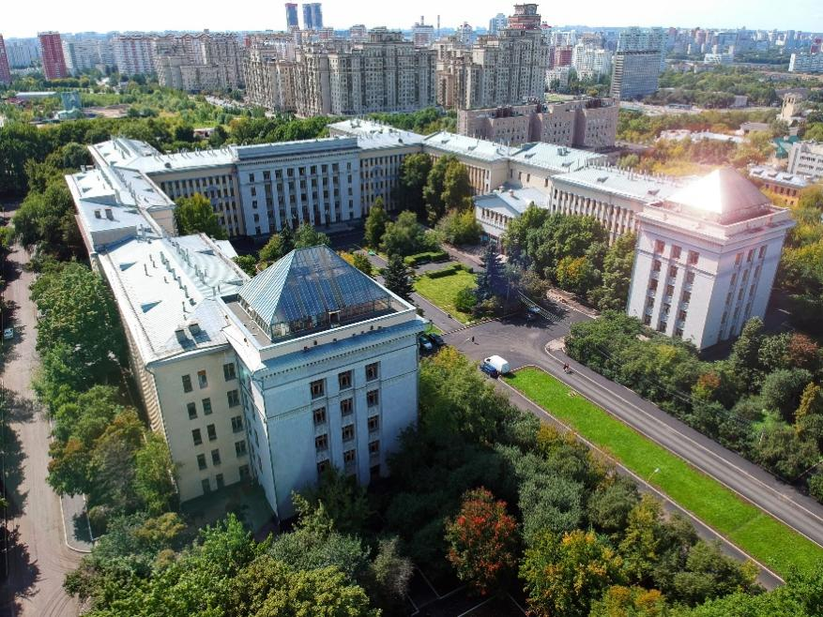

**We are looking forward to welcoming you at the Conference!**

**Organising committee**